Chapter 14, Solution 61.

- 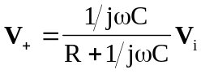, 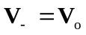

Since 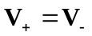,
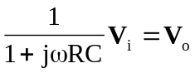

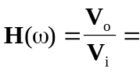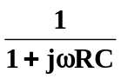

- 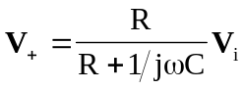,

Since ,
